Prepositional Phrase (PP) as Head

🟩 What is Prepositional Phrase (PP) as Head
# Source: AI Source: Provided by: [Data Path: Persons Table -> ID Column: 1, Name_En Column: Motasem Essam] -> From: [Chatgpt (GPT‑5 Mini)] on [8/7/2025]
A Prepositional Phrase (PP) is a phrase that begins with a preposition, which acts as the head of the phrase. It typically consists of the head preposition followed by a complement, often a noun phrase or clause.

🔹 Structure of a Prepositional Phrase
# Source: AI Source: Provided by: [Data Path: Persons Table -> ID Column: 1, Name_En Column: Motasem Essam] -> From: [Chatgpt (GPT‑5 Mini)] on [8/7/2025]
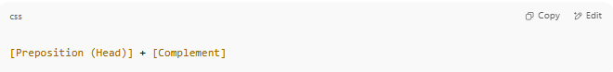
[Preposition (Head)] + [Complement]

Example:
in the room → "in" (head preposition) + "the room" (noun phrase complement)

🔹 Common Types of Prepositional Phrase Heads
# Source: AI Source: Provided by: [Data Path: Persons Table -> ID Column: 1, Name_En Column: Motasem Essam] -> From: [Chatgpt (GPT‑5 Mini)] on [8/7/2025]
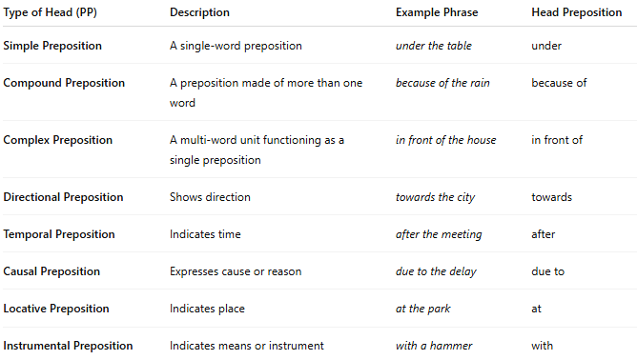
Type of Head (PP) | Description | Example Phrase | Head Preposition
Simple Preposition | A single-word preposition | under the table | under
Compound Preposition | A preposition made of more than one word | because of the rain | because of
Complex Preposition | A multi-word unit functioning as a single preposition | in front of the house | in front of
Directional Preposition | Shows direction | towards the city | towards
Temporal Preposition | Indicates time | after the meeting | after
Causal Preposition | Expresses cause or reason | due to the delay | due to
Locative Preposition | Indicates place | at the park | at
Instrumental Preposition | Indicates means or instrument | with a hammer | with

✅ Key Notes:
# Source: AI Source: Provided by: [Data Path: Persons Table -> ID Column: 1, Name_En Column: Motasem Essam] -> From: [Chatgpt (GPT‑5 Mini)] on [8/7/2025]
- The preposition is the head because it determines the function of the whole phrase (e.g., time, place, direction).
- The complement is usually a noun phrase, but it can also be a clause or gerund.

